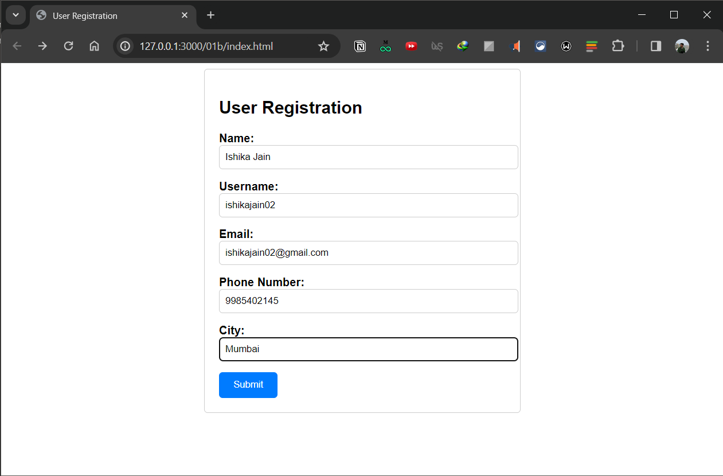**WADL Assignment 1b**

(Index.html)

(display.html)